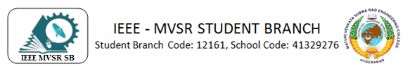

Three Day Workshop on Recent Trends in Green Technologies
IEEE MVSR PES Student Chapter, in collaboration with EEE department MVSREC, had conducted a Three Day Workshop on the Recent Trends in Green Technologies from 19th to 21st December, 2019.

Student Branch Mentor:

Dr. Atul Negi,
Professor, School of CIS,
University of Hyderabad.

Student Branch Advisor:

Mr. V. Ashwini Kumar, Assoc. Professor, IT Dept., MVSR Engineering College.

PES Advisor:
Dr. D. Hari Krishna,
Assoc. Professor, EEE Dept.,
MVSR Engineering College.

Students Branch Executive Committee:

R. RamyaSree - Chairperson
K. Akshitha - Vice Chair
M. Shreya - Secretary
K. Vinay Kumar - Joint Secretary
V. Vineeth - Treasurer
P. Varun Kumar-Operating committee Head

Computer Society:
S. Sai Teja - Chair
G. Suradhya - Vice Chair
M. VamsiKrishna - Secretary
A. Phani Sahasra - Joint Secretary

V. Manikanta- Treasurer

Circuits and Systems Society:
D.Siddartha -Chair
K.Jaideep -Vice Chair
D.V.B Parthiv -Secretary
D.Venkat -Joint Secretary
P.Shravya -Treasurer
WIE Student Branch Advisor:

Mrs. Dr. G. Kanaka Durga,
Principal,
MVSR Engineering College.

Student Branch Counsellor:

Dr. D. Hari Krishna,
Assoc. Professor, EEE Dept.,
MVSR Engineering College.

CS student branch advisor:
Mrs. B. Saritha
Assoc. Professor, CSE Dept.,
MVSR Engineering College

CASS Student Branch Advisor:
Mrs. S. Aruna
Asst. Professor, ECE Dept.,

MVSR Engineering College.

WIE Affinity Group:

A. Sai Pratyusha - Chairman
M. Shresta - Vice Chair
Sahithya Namani - Secretary

L. Ruthvika - Joint Secretary
R. Ruchitha - Treasurer

Power Energy Society:
E. PavanKumar - Chair
Jayasree K - Vice Chair

N. Avinash - Secretary
B.Nikita Reddy - Joint Secretary

S. Satvika - Treasurer

Operating Committees:
Ch. Jinesh- Publicity Committee
M.V.S.S.S.R Sahith-Membership Committee
Hemish& Y. Sai Sameer - Design Committee

M. Sai Sri Teja- Program Committee
Session details:

Date : 19th December – 21st December, 2019.
Time : 9.30 am–4.00 pm.
Venue: Mechanical conference hall, MVSREC.

Speakers:
Dr. P. Subramanyam, Professor CMRCET
Mr. M. Raveendra Reddy, Asst.Professsor, EEED, MVSREC
Dr. B. Mangu, Professor, UCE, Osmania University
Dr. E. Vidya Sagar, Vice Principal & Associate Professor, UCE, Osmania University
Dr. P. Satish Kumar, Associate Professor, UCE, Osmania University
Dr. P. Chander Shekar, Technical Director, TDG.
Dr. D. Hari Krishna, Associate Professor, EEED, MVSREC
Mr. YLN Rao, Assistant Professor, EEED, MVSREC
Mr. Srinivasulu, trainer, Pantech Pro Ed.
Dr. D. Sreenivasa Rao, Assistant Professor, NIT Warangal
Mr. G. Srinivas Sharma, Associate Professor, MED, MVSREC
Mr. C.V.G.K. Rao, HOD &Associate Professor, EEED, MVSREC
Dr. G. Ravindranath, HOD & Professor, EEED, MEC

Agenda:

Day 1
Key note by Dr.P.Subrahmanyam
Lecture on Current scenarios in Renewable energy
Lecture on Power evacuation strategies for hybrid photovoltaic and wind energy systems
Lecture on Smart Grid

Day 2
Lecture on PWM & Multilevel Inverters
Lecture on Energy Auditing, Renewable Energy sources
Hands on Session

Day3
Lecture on Power electronic converters for Electric Vehicles
Lecture on Combined Heat and Power & Economic load dispatch
Lecture on Challenges for Green Technologies

Day 1 - 19th December, 2019:
The workshop was inaugurated by Professor S.G.S Murthy, Vice Principal MVSREC, Dr. P. Bala Subramanyam, Chief Guest, Professor, CMRCET, Head EEE Mr. CVGK Rao, Workshop Coordinators Dr. D. Hari Krishna, IEEE MVSR SBC and Mr. YLN Rao. Asst. Prof. EEED, MVSREC.
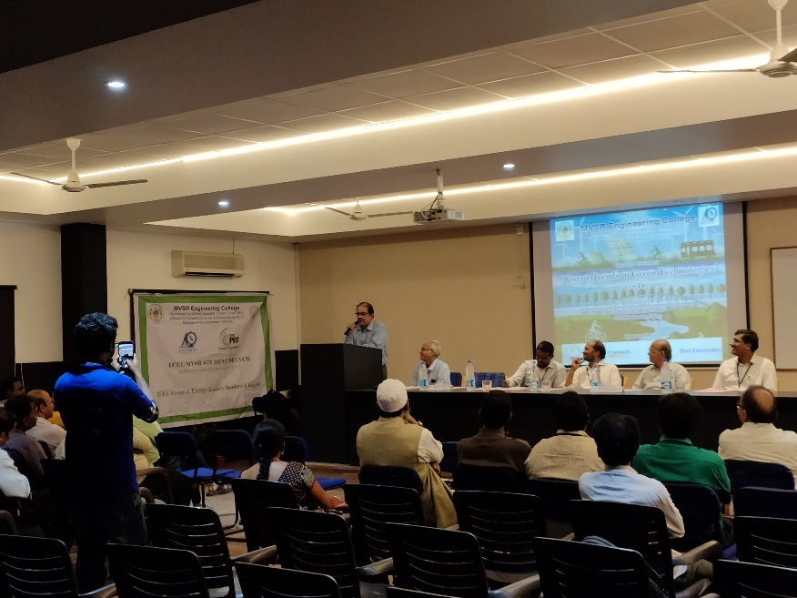
Professor S.G.S Murthy, Vice Principal MVSREC.

Then, Dr.P. Subramanyam, professor CMRCET, gave a keynote addressing regarding the recent trends in the field of green technologies, explaining the theme of the workshop to all the audience. He gave a brief description of the concepts that will be discussed in the workshop.

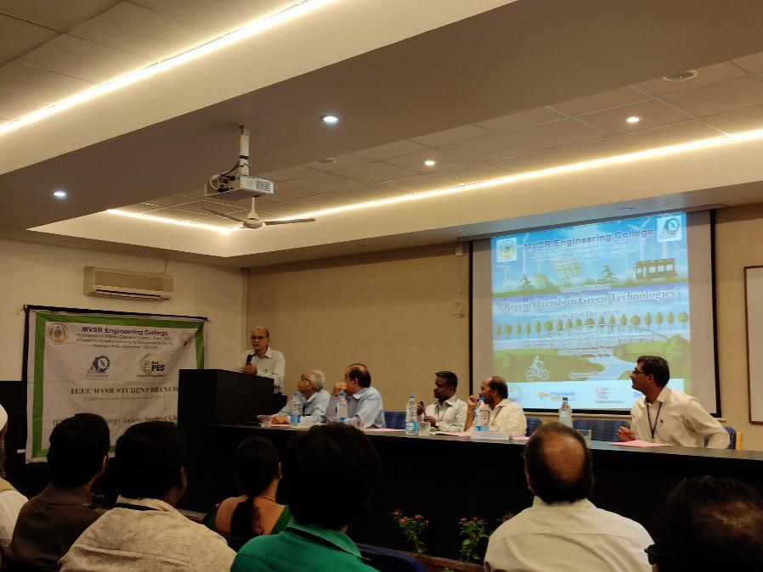
Dr.P.Subramanyam, professor CMRCET, giving the keynote.

The session was then continued by Mr. M. Raveendra Reddy, Asst.Professsor, EEED, MVSREC, who explained the Current Scenario of renewable energy sources. He said that the world is in great need of renewable energy sources as we all will be running out of the sources and that, the need of energy will be never decreasing.

The next session was by Dr. B. Mangu, Professor, UCE, Osmania University. He discussed about power evacuation strategies for hybrid photovoltaic and wind energy systems. A brief explanation about the hybrid systems, its significance and working was given.

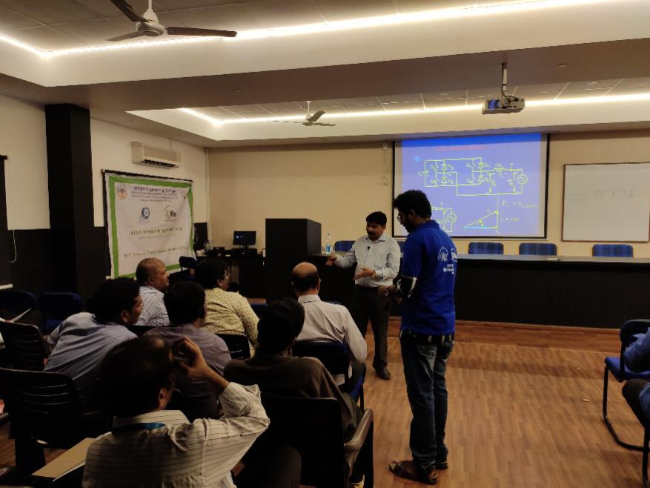
Dr.B.Mangu, Professor, UCE, Osmania University, discussing pvwsm.

Dr. E. Vidya Sagar, Vice Principal & Associate Professor, UCE, Osmania University, concluded the session for the day by explaining how Smart Grid would create an evolution in the electrical industry, its advantages and its enormous capability of producing electric energy without wasting much of it.

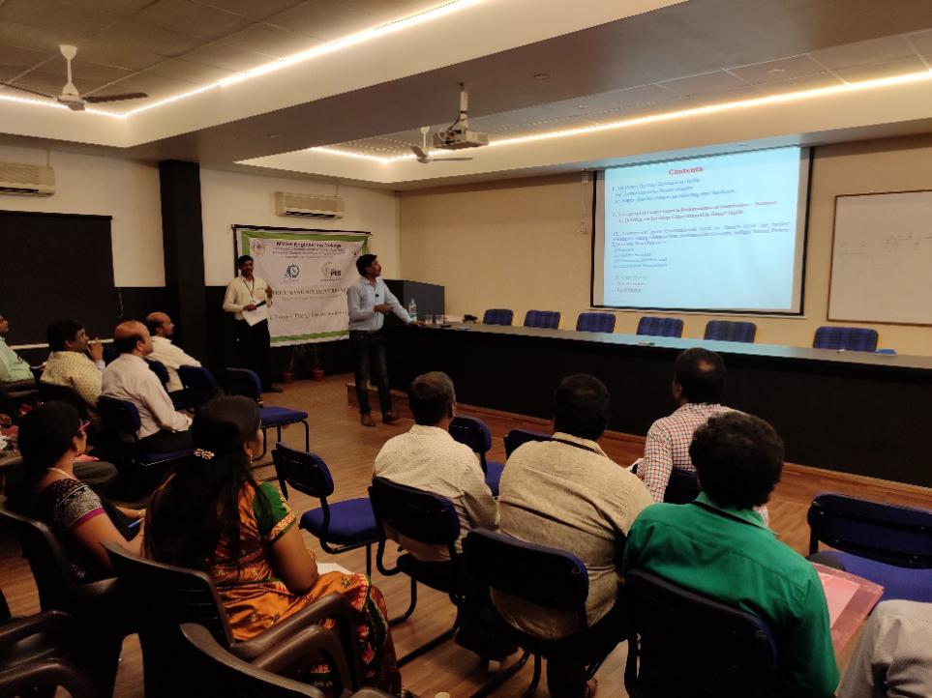
Dr. E. Vidya Sagar, Vice Principal & Associate Professor, UCE, Osmania University

Day 2 - 20th December, 2019:
Dr. P. Satish Kumar, Associate Professor, UCE, Osmania University, started the session by briefing about pulse width modulation techniques, single PWM, multiple PWM, sinusoidal PWM, their advantages, wide range of application and multi-level inverters.
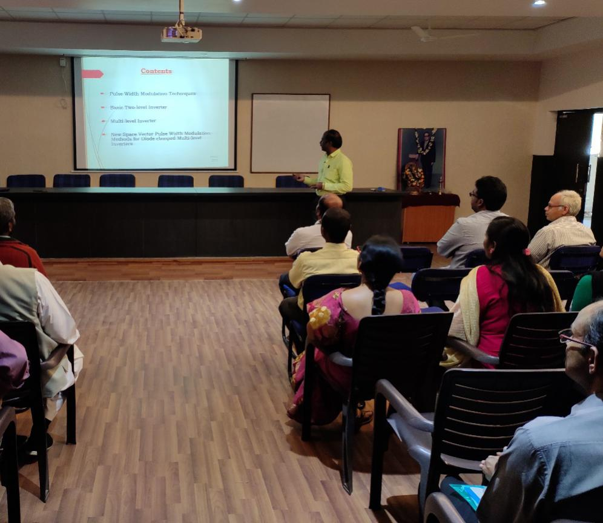
Dr. P. Satish Kumar, Associate Professor, UCE, Osmania University about PWM and MLI.

Dr. P. Chander Sekar, Technical Director, TDG continued the session on accounting and auditing the energy, home energy auditing and industrial energy auditing. The next session was on basics of renewable energy sources i.e. solar, wind and hybrid energy and various circuits related to the renewables Dr. D. Hari Krishna and Mr. Y.L.N. Rao. The session for the day was concluded with a hands on session by Mr. Srinivasulu, Trainer, Pantech ProED on the circuits related to renewable energies to the participants.

Day 3 - 21st December, 2019:
Dr. D. Sreenivasa Rao, Assistant Professor, NIT Warangal, started the session by explaining various power electronic converters for electric vehicles, their need, significance, topologies and design.
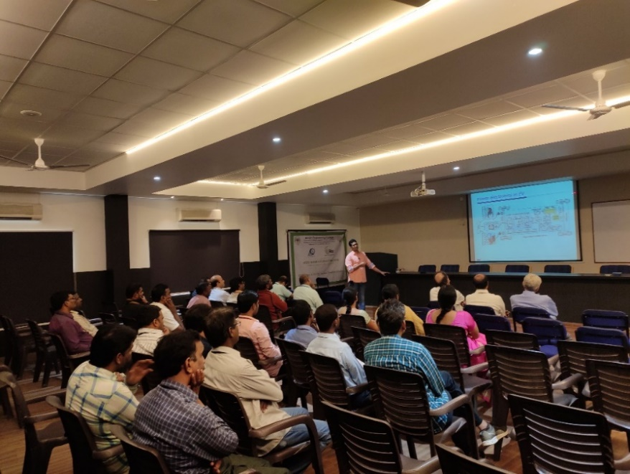
Dr. D. Sreenivasa Rao, Assistant Professor, NIT Warangal about converters in EVs.
The next session was delivered by Mr. G. Srinivas Sharma, Associate Professor, MED. His lecture was on the topic the key part of energy future – combined heat and power.
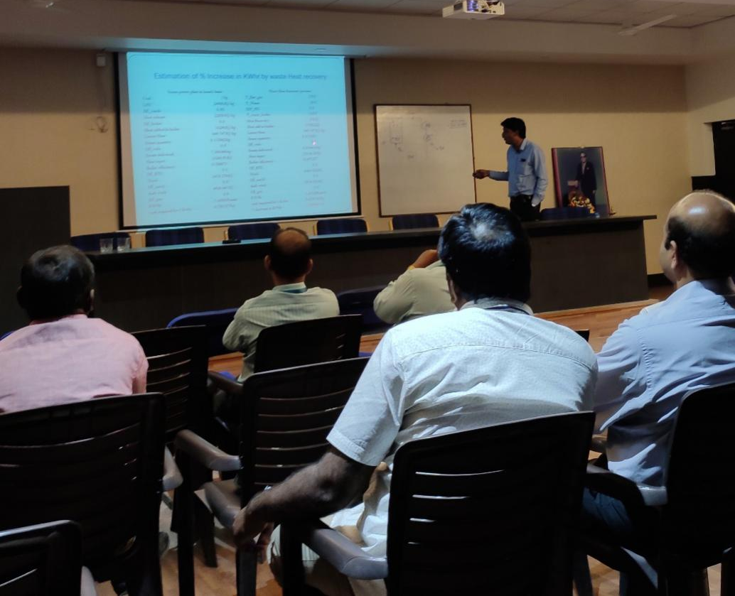
Mr. G. Srinivas Sharma, Associate Professor, MED

Later, Mr. C.V.G.K. Rao, Head EEED, MVSREC, shared his ideas and work related to the economic load dispatch of combined heat and power.
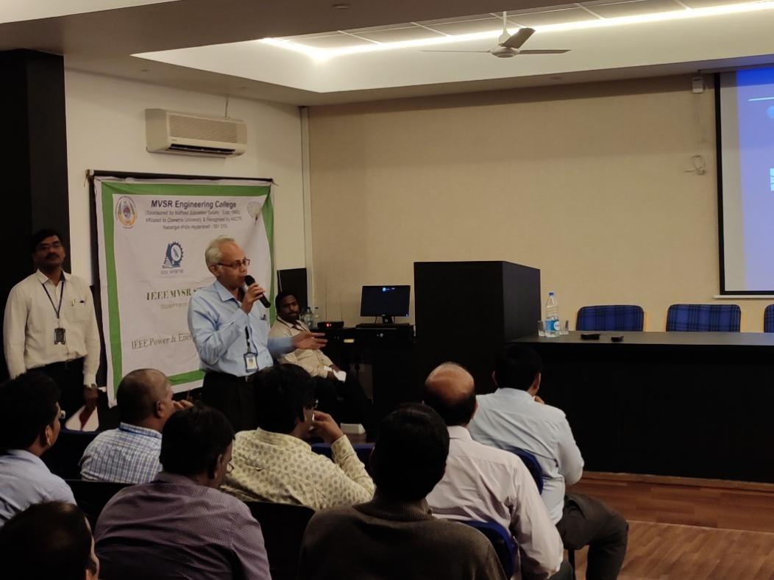
Mr. C.V.G.K. Rao, Head, EEED, MVSREC

Dr. G. Ravindranath, HOD & Professor, EEED, MEC, concluded the session by discussing the challenges that are being faced by Green Technologies.

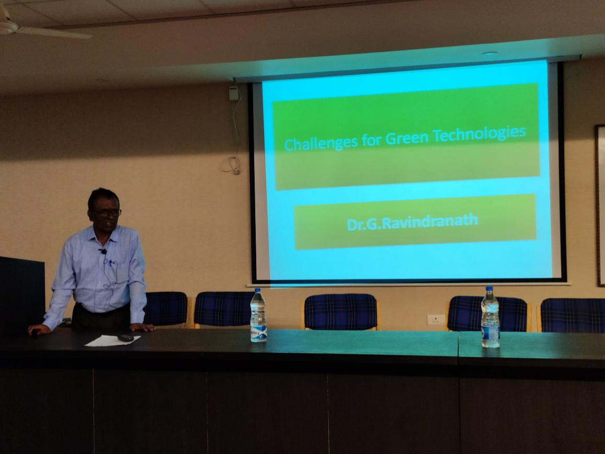
Dr. G. Ravindranath, HOD & Professor, EEED, MEC about challenges for green technologies

The Workshop was concluded with a valedictory function includes felicitation of Dr. G. Ravindranath by Mr. C.V.G.K. Rao, Head EEED and Dr. D. Venu Madhava Chary, Professor EEED, distribution of certificates to the participants.

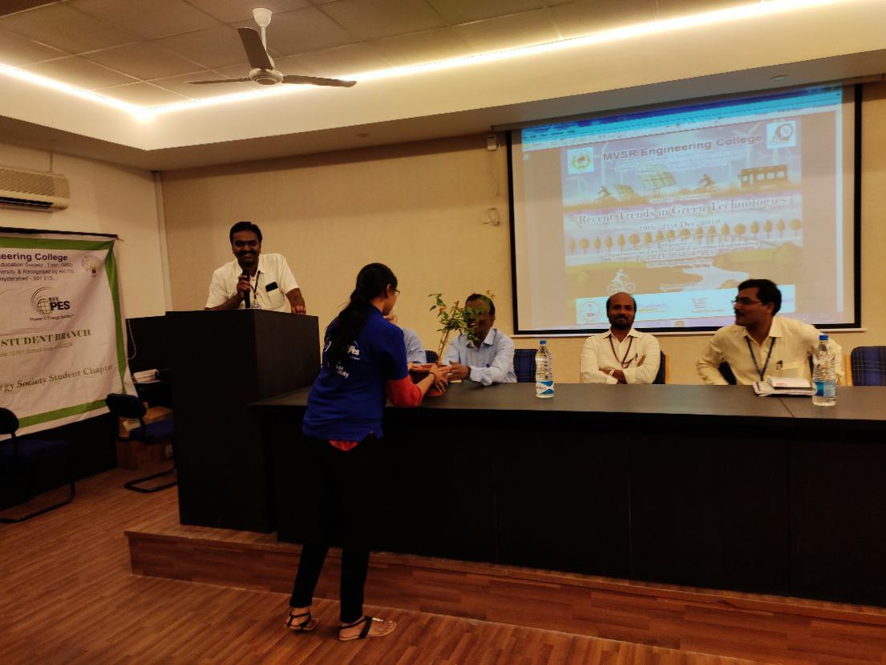
Valedictory and Felicitation of Dr.G.Ravindranath.

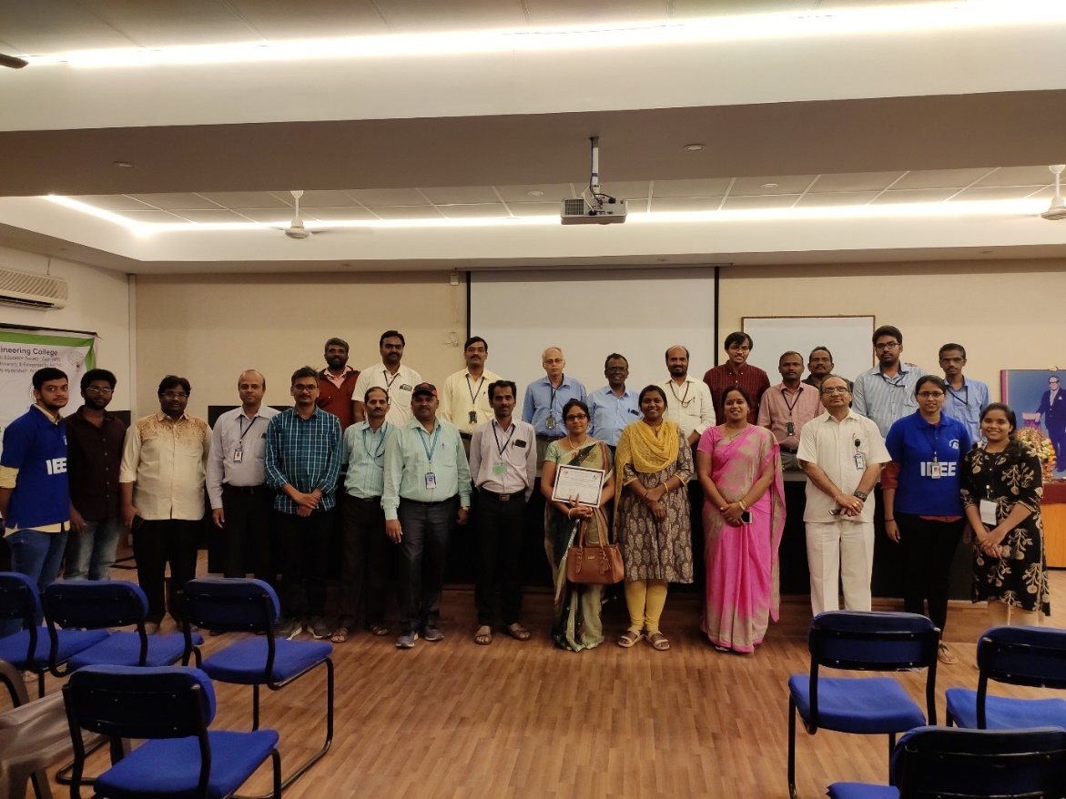
Group photo with the dignitaries, participants and RTGT team

Reported by:
IEEE MVSR SB.

